**Using Oxford Music Online**

**(including Groves Music Online)**

*Oxford Music Online* (OMO) searches the following scholarly resources, either individually, all at the same time, or in various combinations thereof:

* *The Oxford Companion to Music* (2002)
* *The Oxford Dictionary of Music*, 2nd edition (revised 2006)
* *Encyclopedia of Popular Music*, 4th edition (2006)
* *Grove Music Online - containing*
  + ***New Grove Dictionary of Music and* *Musicians*** (2nd edition) 29 vols.
  + *New Grove Dictionary of Opera*, 4 vols.
  + *New Grove Dictionary of Jazz* (2nd edition). 3 vols.

Oxford Music Online (OMO) is comprehensive and authoritative:

* Covers the entire history of music from Bach to the Blues
* Broad coverage of musical styles
* Updated regularly with new and revised articles
* Detailed composers' works lists
* Extensive lists of additional research resources
* Powerful search tools

*The New Grove Dictionary of Music and Musicians*, 2nd edition (2001), *-* 50,000 articles by 6,000 contributors, 30,000 biographies, sophisticated search and browse capabilities, over 500 Sibelius-enabled musical examples, and extensive links to musical sites on the Internet, making it the unsurpassed authority on all aspects of music.

*The Oxford Companion to Music* (2002), which offers more than 8,000 articles on composers, performers, conductors, instruments and notation, forms and genres, and individual works; and

*The Oxford Dictionary of Music*, 2nd edition (revised 2006), which supplements Grove's more extensive articles with content geared toward undergraduates and general users. Both of these sources are included in subscriptions to *Grove Music Online*.

*Encyclopedia of Popular Music*, 4th edition (2006). The most comprehensive reference work devoted exclusively to popular music, EPM is the authoritative biographical encyclopedia of rock, pop, and jazz artists, covering popular music from 1900 to the present. It is exhaustive, meticulous, authoritative — and incredibly fun to read.

**Sample Search 1**

At the OMO home page search for Aaron Copland (upper, right hand corner).

Notice the different sources – *Grove Music Online, Oxford Companion to Music, Oxford Dictionary of Music*, each have an entry. Take the time to compare them. While some of this information will be redundant, you can get additional and sometimes unique information, by examining more than one source.

Reopen the Grove Music Online article (located on the left) and note the article contents on the left side. Open up the expandable + list to show all the subtopics.

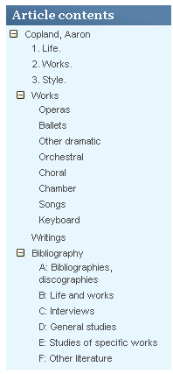

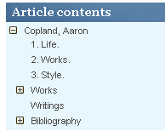

Click on Ballets to hyperlink to a list of ballet works.

Click on Studies of specific works and find a scholarly source on Copeland’s score for the *Red Pony*.

**Sample search #2**

At the OMO home page type in “Mozart” in the search screen (upper, right hand corner)

Notice that you get almost 4,000 hits covering six different Mozarts, the Mozart family, and many Mozart-related articles such as Mozart and Salieri, London Mozart Players, and ‘Mozart” fifths.

Find the main article about **Wolfgang Amadeus Mozart** and examine it. Hint. It is from *Grove Music Online*, and it is a (Biography).

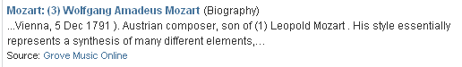

Notice that while this is actually part of a larger article containing all of the Mozarts, you are only being shown part (3) Wolfgang Amadeus Mozart.

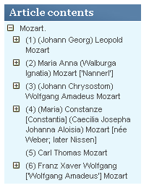

Click on the plus sign to open up the articles contents. Then hyperlink to the section on Vienna. When did Mozart return to Vienna?

Sample Search #3

Sample Questions:

1. You are unsure of how to spell the last name of Giovanni Francesco Sabeno? Sabino? Sabieno? But you are sure it starts with “Sab”. Hint: Click on Subject Headings and search for “Sab”. Sabino
2. Who rescued the timpani aournd 1800? Beethoven
3. Where can you find a list of women composers by time period? Hint: Use the Tools and Resource Tab (top of page) and scroll down to Women Composers. Cklick on the By Time Period Tab.
4. Find a list of musical examples that you can listen to? Listen to one. Hint: Use the Tools and Resource Tab (top of page). Scroll down to Guide to Musical Examples in Grove Music Online and pick an example. (You will have to download [Sibelius Scorch PlugIn](http://www.sibelius.com/cgi-bin/download/get.pl?com=sh&prod=scorch) to your computer.)
5. How many operas did Ottorino Respighi write? 10
6. How do I cite the above article? Hint: Click on the small orange Cite Tab near the upper right hand corner and choose the MLA example. Due to the fact that Oxford Music Online consists of more than a half dozen different titles, this is a good way to make sure you are citing the right source. However, although the example provided by the database is close to proper MLA form, you will need to double check it against the handout

**Online Example:**

John C.G. Waterhouse, et al. "Respighi, Ottorino." Grove Music Online. Oxford Music Online. 13 Sep. 2010 <http://www.oxfordmusiconline.com/subscriber/article/grove/music/47335>.

**Corrected Citation:**

John C.G. Waterhouse, et al. "Respighi, Ottorino." Grove Music Online. Oxford Music Online. Web. 13 Sep. 2010.

1. Does Groves list more than a dozen scholarly sources on Antonio Salieri? Hint: Check the Bibliography at the end of the main article.Yes
2. Find an illustration (image) of Tempo.
3. Who was Sa-Chi? Béla Szakcsi Lakatos

Notice that the article is over 40 pages long, so printing is not a good option. You may want to consider bookmarking the article, saving it to your computer, or emailing it to yourself. A digital copy will also be helpful if you wish to copy and paste portions into your paper.

Due to the extreme length of some articles, browsing for something specific can be a challenge. Instead, use the Article Contents on the left side of the screen. Open all the +’s until you find the Vocal Works of Mozart. Then hyperlink to them.

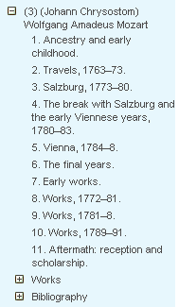

1. Do an Edit / Find search for a key word, such as **“Figaro**”. This will allow you to move forward through the article every time that word is used.

This time let’s narrow down our search using the more specific topic **Wolfgang Amadeus Mozart.** This time we have far fewer hits, but it becomes more apparent that we are finding things which aren’t obviously connected to our search term.

Click on Mozart # - **Wolfgang Amadeus Mozart**

Searching - **Wolfgang Amadeus Mozart**

Full Text – 500+

* Choose Mozart (the family) notice that there are six Mozart’s.
* Wolfgang Amadeus is no.3.

Browse Articles A-Z – 2 Last name first. Good if you don’t know spelling.

Search Box – (upper right hand corner) – 2 Faster.

Index – Finds topics. Last name first. Then use **+** to browse subtopics – dozens

* Find sonata form

Leads to an article about Sonata form which discusses Mozart’s sonatas

Explore

Explore biographies. Allows you to find people by time period, genre, gender, and country,

Guide to Sibelius Music Examples

Sound samples. Have to download [get Scorch](http://www.sibelius.com/cgi-bin/download/get.pl?com=sh&prod=scorch)Sibelius Scorch

Works are arranged chronologically

Subheadings on left match those within article

[Mozart, Wolfgang Amadeus, §2](http://www.grovemusic.com/shared/views/article.html?from=search&session_search_id=689356368&hitnum=25&section=opera.007498.2) Opera Subtopic

Need Bound books – Vols. **Mozart** and **Index** and **Sonata**.